**Defect Id**:

B001

**Issue Type:**

Bug

**Summary**:

User can add a product to favorites even not logged in

**Description:**

Pre-requisite:

1. User is not logged in

Steps:

1. Click [SAVED TO FAVOURITES]

2. Enter email

3. Enter password

4. Click [Create New Account]

**Actual Result:**

User is able to add a product to favorites even not logged in

**Expected Result:**

User should not be able to add a product to favorites if not logged in.

**Environment:**

Firefox 83.0b2

**Priority:**

P3

**Severity:**

Minor

**Attachment:**

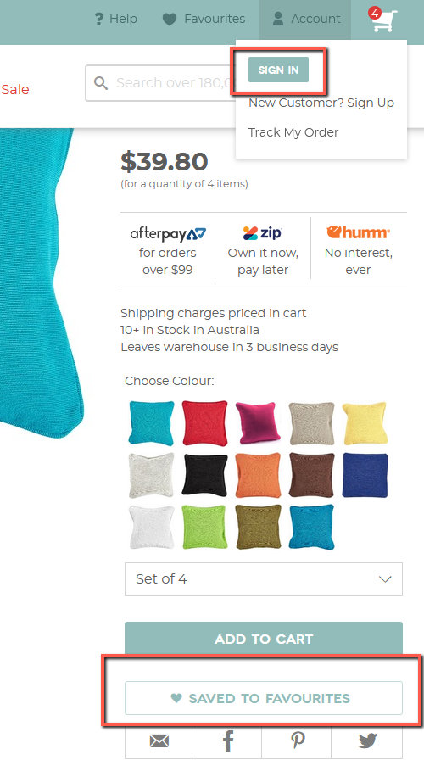

**Assignee:**

N/A

**Reporter:**

Serniel Barbosa

**Defect Id**:

B002

**Issue Type:**

Bug

**Summary**:

Log in for an existing account is intermittently showing to Add to favorites pop up

**Description:**

Pre-requisite:

1. User is not logged in

Steps:

1. Click [SAVED TO FAVOURITES]

2. Enter email

3. Close

4. Repeat step 1 and 2 but use different existing email

**Actual Result:**

Log in for an existing account is intermittently showing to Add to favorites pop up

**Expected Result:**

If user is already logged in, product should automatically add to favorites.

If user is not logged in, pop should initiate registration or login

**Environment:**

Firefox 83.0b2

**Priority:**

P3

**Severity:**

Minor

**Attachment:**

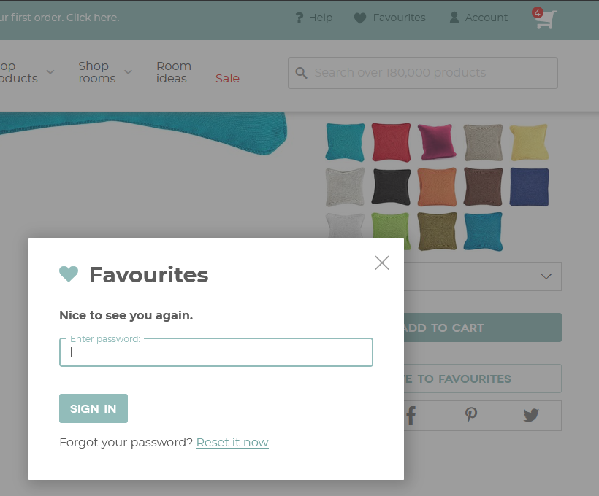

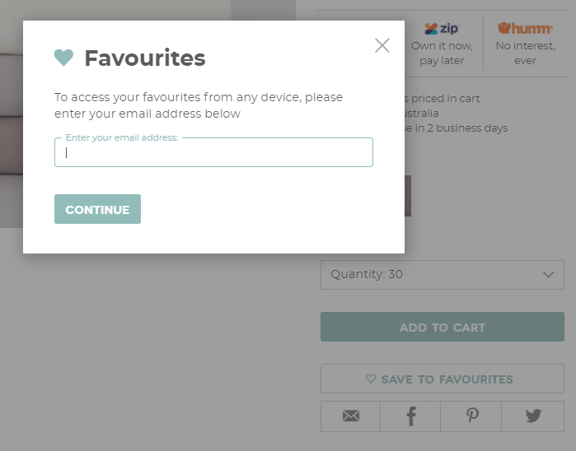

**Assignee:**

N/A

**Reporter:**

Serniel Barbosa

**Defect Id**:

B003

**Issue Type:**

Bug

**Summary**:

Pinterest and Twitter icons doesn't have an element popping up when mouse hovered

**Description:**

Steps:

1. Mouse hover to Pinterest and Twitter icons

**Actual Result:**

Pinterest and Twitter icons doesn't have an element popping up when mouse hovered

**Expected Result:**

Pinterest and Twitter icons should have an element popping up when mouse hovered

**Environment:**

Firefox 83.0b2

**Priority:**

P3

**Severity:**

Minor

**Attachment:**

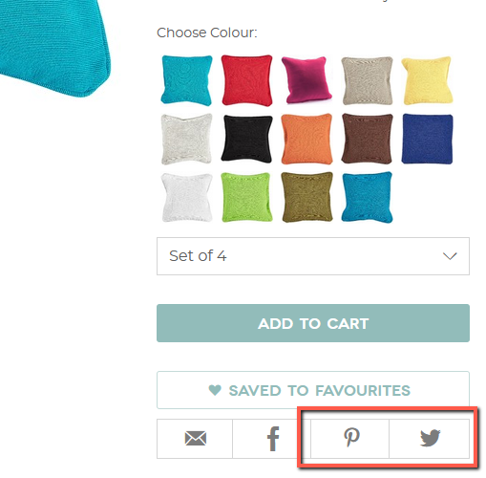

**Assignee:**

N/A

**Reporter:**

Serniel Barbosa

**Defect Id**:

B004

**Issue Type:**

Bug

**Summary**:

Vote for reviews is not adding in real time

**Description:**

Pre-requisite events:

1. User is logged in

2. User is not logged in

Steps:

1. In Review section, click a like button to any reviews

2. Refresh the page

3. Verify count in reviews section

**Actual Result:**

Like or dislike is not counted.

**Expected Result:**

Like or dislike should be counted in real time.

**Environment:**

Firefox 83.0b2

**Priority:**

P3

**Severity:**

Minor

**Attachment:**

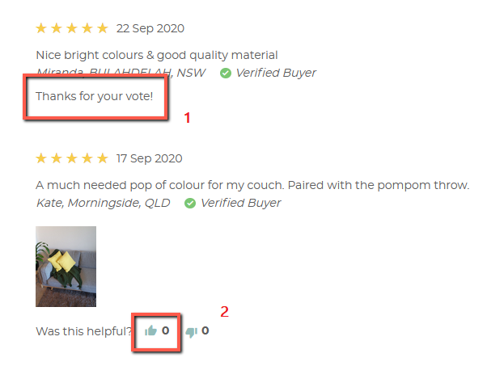

**Assignee:**

N/A

**Reporter:**

Serniel Barbosa

**Defect Id**:

B005

**Issue Type:**

Bug

**Summary**:

Clicking photo navigation is not working

**Description:**

Steps:

1. Click the circles under the photos to navigate

**Actual Result:**

Nothing happens

**Expected Result:**

Clicking the circles should navigate photos. Same functionality with swipe.

**Environment:**

Galaxy X

**Priority:**

P3

**Severity:**

Minor

**Attachment:**

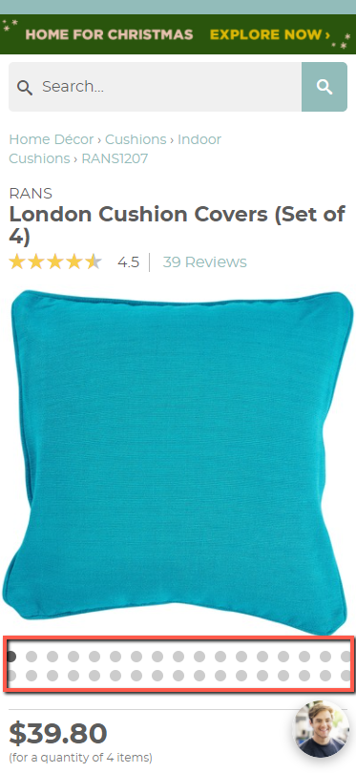

**Assignee:**

N/A

**Reporter:**

Serniel Barbosa

**Defect Id**:

B005

**Issue Type:**

Bug

**Summary**:

[Notify me] is not working

**Description:**

Steps:

1. Select an out of stock product

2. Click [Notify Me]

**Actual Result:**

Nothing happens

**Expected Result:**

A pop up should display in center.

**Environment:**

Galaxy X and IPhone X/XS iOS 12

**Priority:**

P3

**Severity:**

Minor

**Attachment:**

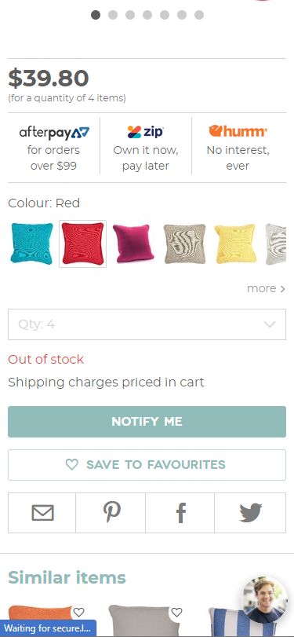

In iPhone X

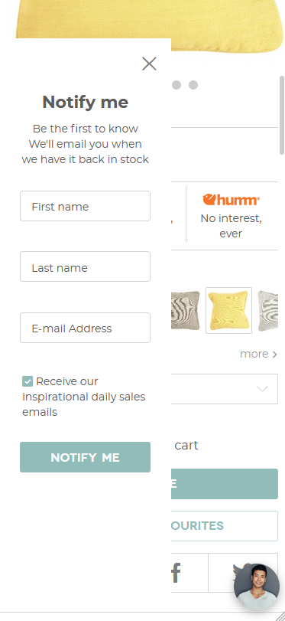

**Assignee:**

N/A

**Reporter:**

Serniel Barbosa